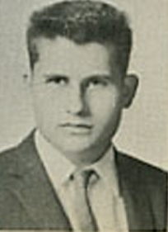 | Edward M. (Mike) Duiven  OHHS Class of ‘59 | 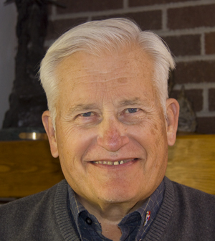
It has come to my attention that it has been nearly 50 years since we graduated from OHHS and, for that matter, nearly that long since I have seen many of you. The upcoming reunion leads me to wonder what ever happened to all of you and you might be thinking the same about me.
Unfortunately, I will not be coming to the Class Reunion this summer due to a previous commitment to work as a Guest Service Agent at Yellowstone National Park from midMay until early October. Consequently, I thought I might take a bit of time and bring you up to speed.
As I recall, I was an awful student at OHHS and graduated somewhere near the bottom of our class. One of our faculity advisors actually suggested that I “join the Army” since I was too dumb to go to college. With those words ringing in my ears, I headed off to Grand Rapids Junior College to work on getting smart and, at the same time, to try to figure out what I wanted to do when I grew up. Those two years saw a metamorphasis of my acedamic capabilities and I developed a vision of what I might want to do.
In the fall of 1961, after caddying for the Western Open at Blyfield Country Club, I found myself on campus at the University of Michigan. I was enrolled in the College of Engineering. Within three months I had met a young lady, Pat, who would become my wife and to whom I have been married for nearly 45 years. During my years at the UofM I spent a lot of time studying (something I hadn’t done until my senior year in high school), worked a number of jobs to pay for the educational experience, and spent some time picking up a pilots license. Upon graduation from the UofM, with a Bachelors Degree in Aeronautical Engineering, Pat and I were married and we moved to Los Angeles where I worked for the Hughes Aircraft Co. Hughes was going to send me to graduate school but, after working for Hughes for 9 months, I left there and we moved to Palo Alto, CA where I metriculated at Stanford University.
Four years at Stanford netted me a Masters Degree and an Engineers Degree both in Aerospace Engineering. I was very lucky to have a scholarship form NASA which paid all my school expenses and our living expenses as well. However, after 8 years in college, it seemed like getting a job would be a good idea. Pat wanted to start a family and I wanted to start to apply what I had been studying.
So, in June of 1968, Pat and I picked up and moved to Seattle, WA where I took a job with The Boeing Aircraft Co. I spent four years with Boeing. During that time we adopted a son, Christopher, and had a natural born son, Scott, 9 months later. We loved the Pacific Northwest but Boeing was not doing too well and had laid off about 100,000 employees. Perhaps you recall the sign that read, “Would the last person out please turn off the lights.” Well, I had a family to feed and decided that a change of employment would be good for me.
After looking around a bit I captured a job with a company called The Analytic Sciences Corporation (TASC) which was located in Reading, MA. We picked up the family, in the Spring of 1972, and headed East. I stayed with TASC for 27 years. The company grew from 75 folks when I hired on to over 5,000 when we parted company. Our family also grew with the addition of a daughter, Jennifer, who was born in 1975. During my 27 years with TASC I was involved in the evaluation of navigation/guidance systems for aircraft and missiles, with support of the intellegince community, and with the sale of weather systems around the world. TASC was a great place to work until it was sold to another company. That marked the beginning of the end for me.
The kids began to marry and leave home and I “retired with encouragement” in 1999. Pat and I moved to a small town in the Colorado Rockies – Buena Vista, CO. Since the move we have been busier than when we worked. We constructed an Amature Built or Experimental Aircraft (RV-9A), got involved with quilting, traveled a bit and are currently splitting our time between CO and Green Valley, AZ. The Country Club of Green Valley sees Pat and I playing a lot of golf.

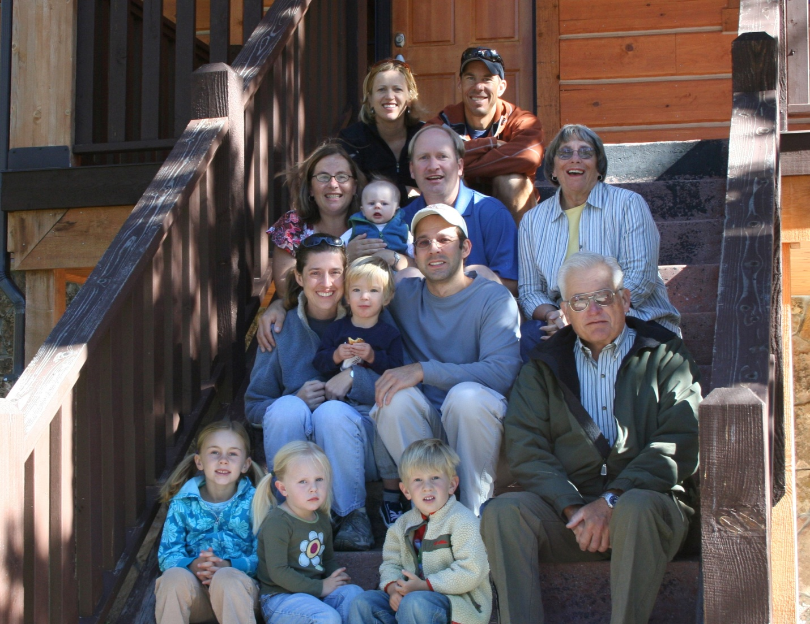
The Duiven Family captured at a reunion last September. From top to bottom and left to right: Alison and Scott Duiven; Jennifer, Mikie, and Sean VanHemelryck; Pat Duiven (wife); Tammi, Donovan, and Christopher Duiven, Mike Duiven (me); Emma Duiven (daughter of Allison and Scott); Jaelyn VanHemelryck; and Willem Duiven (son of Alison and Scott).

